

**Table Of Contents**

Hardware Upgrade 2

Setup 2

Upgraded Network stack 3

Clustering 3

Achieved future plans from V 1.0 4

Future plans and Upgrades 4

Cybersecurity Lab 5

**Hardware Upgrade**

My homelab journey began with a single computer featuring the following specs:

CPU: Intel Pentium dual core

Ram: 4gb

Storage: 260gb HDD

But now I bring Dell Optiplex 7010 and 790 to my homelab.

Dell Optiplex 7010 with specs:

CPU: Intel i5

Ram: 8gb

Storage: 256gb HDD

Dell Optiplex 790 with specs:

CPU: Intel i5

Ram: 8gb

Storage: 150gb HDD

These are the hardware I brought up for my homelab. Still networking equipment are not arranged but this is a major upgrade to my homelab.

**Setup**

Configured Dell Optiplex 790 by installing Promox VE on the system and noted the IP and MAC address of the machine and added the mac to the reserved IP field on the router. Noted the node1 mac and added the mac of node1 to the reserved IP field on the router.

Configured Dell Optiplex 7010 by installing windows 11 on it. Signed in with a Microsoft account.

**Upgraded Network Stack**

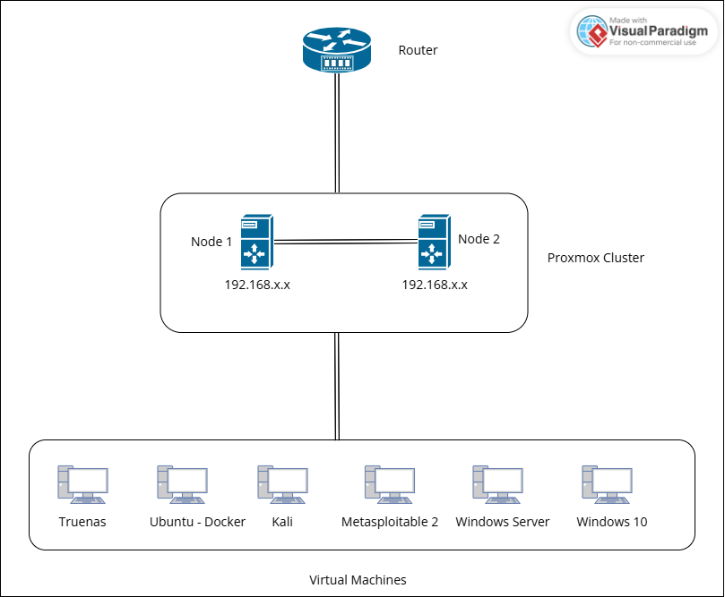

**Clustering**

A Proxmox cluster is a group of servers (nodes) working together to manage virtual machines (VMs) and containers efficiently. Instead of running each server separately, clustering allows them to share resources, improve uptime, and make management easier. Multiple servers, Centralized management, Shared storage, High availability, Load balancing are some features which can be achieved by clustering.

* My Use case in Clustering:

In my case, I have two nodes where one node starts with windows server which will start on boot and another node starts with truenas VM which will start on boot. In Proxmox clustering, it follows a strict quorum where half of the nodes need to be online to make decision like spinning up the vm or anything else.

For my mindset, I need to spin up the windows server without switching on the other node. So, I decided to make a change in the proxmox servers,

running a two node cluster with the fallowing corosync options.

two_node: 1

wait_for_all: 0

With these two options in the "quorum" section of "/etc/pve/corosync.conf". If one of your nodes is down, your VMs will all boot like normal, you can edit your VM configs, backups run, etc. I get these options are bad if you have to use HA, But if you don't, these two options can really make things so much better on smaller setups.

**Achieved future plans from V 1.0**

1. Setting up a Windows Server to delve into on-demand topics like Active Directory and centralized domain management.
2. Creating a malware analysis lab within Proxmox to safely study malicious software in an isolated environment.

**Future Plans and Upgrades**

**Future plans**:

I aim to enhance my learning and hands-on experience by working on various homelab projects, including:

* Installing Pfsense on the server and configure my own
  + Firewall
  + DNS server
  + Content filtering for better control over internet traffic.
  + More and more.
* Setting up a DMZ (Demilitarized Zone) for added security and safe exposure of services to the internet.
* Implementing a CCTV camera system for home surveillance and further experimentation with IoT devices.

**Upgrades:**

Currently, my homelab servers are connected directly to my router. To expand and improve its functionality, I plan to:

* Add networking equipment like access points and a network switch for better connectivity and scalability.

These future projects and upgrades will not only broaden my technical knowledge but also offer opportunities for research and development, helping me explore advanced topics in networking, security, and server management.

**Cybersecurity Lab**

For testing my practical skills, I planned to make a penetration testing lab, Web pentesting setup, SOC to monitor and prioritize tasks which can be automated with atomic red team and many more.